Task 1 Report – Image Enhancement

Objective:
To enhance the visual clarity of two input images using various image processing techniques to prepare them for OCR.

Methods Applied:
- Histogram Equalization (on the Value channel of HSV)
- CLAHE (adaptive contrast enhancement)
- Denoising using Non-local Means
- Bilateral Filtering + Sharpening
- Adaptive Gamma Correction (tuned based on each image's brightness level)
- Morphological Operation
- AutoEncoder
- ESRGAN
-SWinIR

Observations:
- `task1_img2` was very dark and contained significant noise, making it difficult to read the text.
- `task1_img1` had better lighting but required contrast improvement for clearer text edges.

Challenges Encountered:
- Over-enhancement using CLAHE on dark areas caused artificial contrast if `clipLimit` was too high.
- Strong denoising techniques reduced noise but also blurred some text edges.
- Histogram Equalization sometimes gave gray-level outputs due to channel limitations; we resolved this by applying it on the Value channel of the HSV image.
- While displaying color images, using `cmap='gray'` in `matplotlib` was showing distorted visuals—so we used `cmap=None` or removed it for color display.

Results:
- Quantitative evaluation using SSIM showed:
- Bilateral Filtering with Sharpening achieved the best result on `img1` (SSIM = 0.8667) in ‘’SSIM_Output_Image1.txt’’, but Adabtive Gamma is the best visual clarity
- Adaptive Gamma Correction produced the best enhancement for `img2` (SSIM = .9601) in ‘’SSIM_Output_Image2.txt’’
-We experimented with multiple enhancement combinations for each image.
- For `img1`, the best result came from a combination of (Bilateral Filtering + Morphogical + Adabtive Gamma + Sharpening), achieving )SSIM = 0.9182 (.

- For `img2`, the best result came from a combination of (Adabtive Gamma + Sharpening + CLAHE), achieving ) SSIM = 0.8840 (.
- The enhanced images were saved as `enhanced_img1_best.jpg` and `enhanced_img2_best.jpg` and will be used in Task 2 (OCR).
- Side-by-side visual comparisons were provided for both images using custom helper functions.
-SwinIR Results:
- SwinIR was tested with a scaling factor of x4 using the pre-trained model 001_classicalSR_DF2K_s64w8_SwinIR-M_x4.pth The output showed faint text with significant noise, making it less effective for OCR compared to traditional methods like Bilateral Filtering.
ESRGAN Results:
- ESRGAN was applied with a scaling factor of x4 using a pre-trained model optimized for real-world super-resolution, showing improved text edges and better contrast compared to SwinIR
- Note: While some of the original images appeared visually clearer to the human eye, the goal of the enhancement process was not only to improve appearance—but to maximize OCR readability.

Image 1
Original Image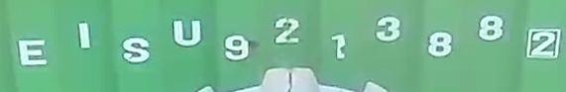Bilateral Filtering with Sharpening (0.86)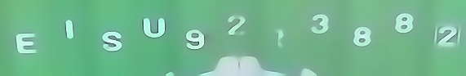
The best visual clarity(adaptive Gamma)
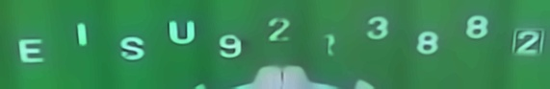
SWinIR
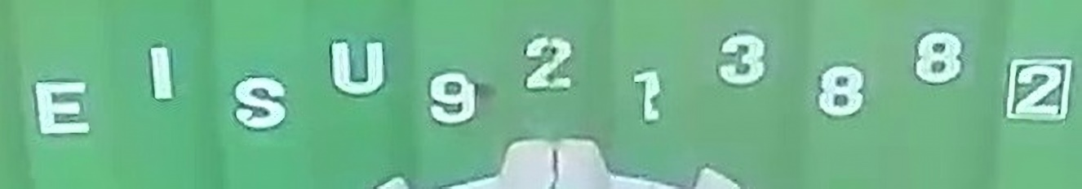

ESRGAN
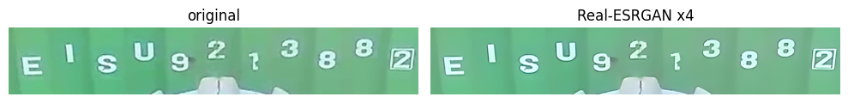

Image 2
Original Image
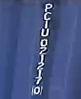

Adabtive Image
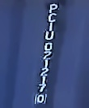

SWinIR
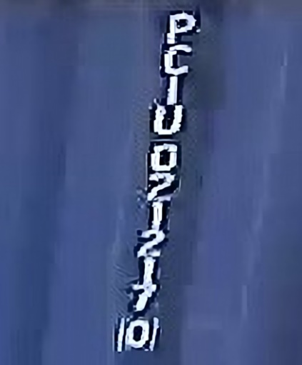

ESRGANs
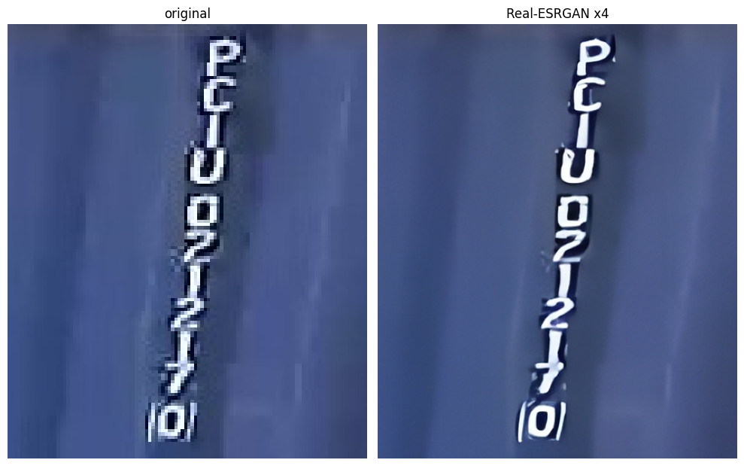

Combination height SSIM
- We applied both pipelines to each image regardless of its type, and computed the Structural Similarity Index (SSIM) to evaluate the quality of enhancement compared to the original.
- Only the best result (with the highest SSIM score) was selected, displayed, and saved for future use in OCR.

